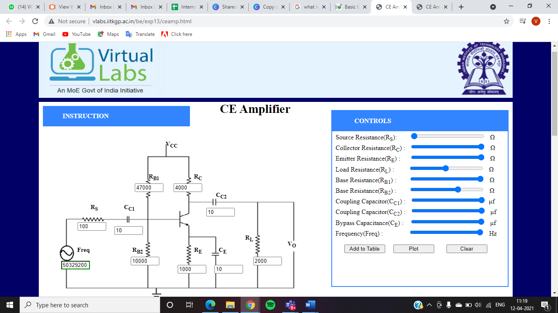

|  |  |  |
| --- | --- | --- |
| **Serial No.** | **Frequency(Hz)** | **Magnitude(dB)** |
| 1 | 50 | 10.599 |
| 2 | 96 | 15.93514 |
| 3 | 220 | 22.813 |
| 4 | 419 | 27.673199999999998 |
| 5 | 727 | 30.916800000000002 |
| 6 | 1264 | 32.9104 |
| 7 | 2004 | 33.7386 |
| 8 | 5033 | 34.279 |
| 9 | 10515 | 34.3632 |
| 10 | 20036 | 34.3814 |
| 11 | 50329 | 34.3864 |
| 12 | 105153 | 34.3842 |
| 13 | 317556 | 34.3512 |
| 14 | 503292 | 34.295 |
| 15 | 2003640 | 33.1026 |
| 16 | 3817860 | 30.8644 |
| 17 | 10515300 | 24.18 |
| 18 | 16665600 | 20.436999999999998 |
| 19 | 50329200 | 10.99534 |

